INSPER – Instituto de Ensino e Pesquisa
UNIVERSITY OF ILLINOIS – Urbana-Champaign
International Projects in Engineering
Global Experience Brazil – AE 398
Fleet Reassignment for Fuel Efficiency:
An Evidence-Based Case for Substituting E1 Jets with E2 Jets on Azul’s Network
Final Technical Report – Team 5
Authors
Eduardo M. R. Souza
Burak Agar
Robert Sanabria
Alexandre Machado
São Paulo / Urbana-Champaign — 2026

Executive Summary
This report consolidates the team’s work on Azul Linhas Aéreas Brasileiras’ operational dataset of 288,337 flights operated between 1 January 2024 and 15 November 2025. The objective set by Azul was to identify implementable, evidence-based opportunities to reduce fuel consumption without assuming a full fleet replacement.
After data cleaning, exploratory profiling and a multi-stage analytical pipeline — operational regime mapping, joint sweet-spot identification, behaviour clustering and a capacity-constrained substitution model — the team concludes that the only aircraft substitution that survives both the fuel-efficiency and the equal-seat-supply screens is the replacement of E1 jets (Embraer 190 family) by E2 jets (Embraer 195-E2 family) on the regional and medium-haul corridors where the two families’ operating envelopes overlap.
Within the seven candidate routes where this overlap is statistically robust, the model estimates a median fuel reduction of 26.6 percent on the substituted segments, equivalent to approximately 480,263 kilograms of jet fuel saved over the analysis window under an equal-seat-supply assumption — with zero additional frequencies required. The two alternative swap directions tested (ATR replacing E1 and A320 replacing A321) fail the capacity screen and are formally rejected.
The recommendation is therefore actionable, narrow in scope, and built on a conservative methodology. It does not require new infrastructure, new aircraft acquisitions beyond Azul’s already ongoing E2 induction, nor changes to the network topology. It does require deliberate equipment allocation on the identified city pairs.

1. Introduction

1.1 Context
Fuel is consistently the largest operating cost line for any commercial airline and the single most material driver of carbon emissions in aviation. For Azul Linhas Aéreas Brasileiras, the structural challenge is compounded by the diversity of the fleet — five distinct equipment families spanning turboprops, regional jets and narrowbodies — and by the geographic breadth of the network, which combines high-density trunk corridors with very thin regional sectors.
This report converts a flight-level operational dataset into a structured narrative about Azul’s fleet behaviour, operational profiles and route-level efficiency opportunities. The analysis proceeds in stages: first the raw sample is described and cleaned, then the typical mission profile of each aircraft family is characterised, and finally a series of controlled comparisons is conducted to test whether specific route assignments could become more fuel efficient without creating a capacity gap.

1.2 Problem statement
Initial feedback received during Checkpoint #1 indicated two weaknesses: fuel efficiency had not been formally characterised, and the proposed adjustments were too generic to be operationally implementable. In response, the team narrowed the research scope from “fleet optimisation” — an open-ended question — to “identification of aircraft reassignment opportunities inside overlapping operational sweet spots”, a question that the available data can actually answer.

1.3 Main research question
How can Azul identify implementable aircraft reassignment strategies across route groups with overlapping operational sweet spots in order to improve operational efficiency without assuming full fleet replacement?

1.4 Sub-questions
- Which city pairs or route groups exhibit overlapping operational sweet spots between aircraft types, making reassignment operationally plausible?
- To what extent do demand fluctuations across routes or seasons justify the reassignment of aircraft types within these overlapping sweet spots?
- How do airport infrastructure and operational constraints limit the feasibility of using larger or alternative aircraft types on specific routes?
- How much potential benefit could these reassignment strategies generate for the airline, based on the operational metrics available in the dataset?
- How sensitive are the identified reassignment opportunities to the analytical assumptions used, particularly seat-based swapability, sweet-spot thresholds, and sample size?

2. Objectives

2.1 General objective
To produce an evidence-based, operationally implementable recommendation that reduces Azul’s fuel consumption on identifiable corridors of its existing network, without requiring a complete fleet replacement.

2.2 Specific objectives
- Clean and validate the operational dataset provided by Azul, isolating an analysis sample whose efficiency metrics are interpretable.
- Characterise the operational regime of each aircraft family (ATR, E1, E2, A320, A321) along the three core mission variables: take-off weight, ground distance and trip time.
- Define a comparable analysis space — the joint sweet spot — within which different aircraft families can be evaluated on equal operational terms.
- Quantify the fuel-efficiency differential between aircraft families inside that comparable space.
- Filter the resulting substitution candidates through a capacity screen, so that any recommendation preserves the route’s seat supply.
- Express the conclusion in actionable form: which equipment to assign to which route group, and what the estimated benefit is.

3. Methodology

3.1 Analytical framework
The methodology follows a funnel structure designed to eliminate spurious comparisons. The full fleet view is intentionally narrowed at each step until only operationally comparable observations remain. The five stages are: (i) data cleaning, (ii) within-aircraft operational characterisation, (iii) joint sweet-spot definition, (iv) fuel-only substitution screen, and (v) equal-seat-supply capacity screen.

3.2 Stage 1 – Data cleaning
The raw dataset contains records that are operationally implausible: negative or null fuel burn, trip times below 10 minutes, ground speeds inconsistent with the equipment type, and fuel-per-nautical-mile values outside any feasible envelope. These records are not artefacts of the operation; they are artefacts of data acquisition and must be excluded before any efficiency metric is interpreted. The cleaning pipeline is fully documented in cleaning_report.csv and removes 230 records out of 288,337 (0.08 percent of the sample).

3.3 Stage 2 – Within-aircraft operational regime
For each equipment family the distribution of take-off weight is characterised through its 10th, 25th, 50th, 75th and 90th percentiles. The interval between P10 and P90 is defined as the operational regime of that family: the take-off-weight band inside which the aircraft is routinely operated. This produces a strict separation between families, which is what allows the subsequent sweet-spot logic to be meaningful.

3.4 Stage 3 – Joint sweet spot
Within each equipment family the best-performing 50 percent of flights — ranked by fuel burn per nautical mile — defines a fuel-efficiency sweet spot. A flight is classified as being inside its aircraft’s joint sweet spot only when it falls simultaneously inside the interquartile ranges of distance, trip time and take-off weight associated with that lower-burn half. This triple-conjunction rule is deliberately strict: it discards flights that look efficient on one axis but are actually atypical on another.

3.5 Stage 4 – Fuel-only substitution screen
On routes where two different aircraft families both operate inside their respective joint sweet spots, a head-to-head comparison of fuel burn per flight is possible. Routes are retained only when both families’ presence inside their own sweet spots is observed in the data — not assumed. For each retained route, the median percentage saving of the more efficient family over the less efficient family is computed.

3.6 Stage 5 – Capacity screen (equal-seat-supply)
Fuel savings per flight are not sufficient for a recommendation. A smaller aircraft may burn less fuel on a single flight but require more frequencies to preserve the route’s seat supply, and these additional flights can erase the saving. The capacity screen attaches a typical seat capacity to each equipment family (ATR ~70, E1 ~106, E2 ~136, A320 ~174, A321 ~214) and recomputes the saving under the assumption that total seat supply on the route is held constant. A swap direction is retained only when (i) total fuel under equal seat supply still decreases and (ii) the implied increase in frequencies is operationally negligible.

3.7 Tooling and reproducibility
All transformations are implemented in Python (pandas, numpy, matplotlib) and the analytical seasonal-decision engine is encapsulated in the azul_seasonal_fleet_decision_engine.py module. The full pipeline — notebooks, the engine, all intermediate CSV outputs and figures — is versioned in the team’s GitHub repository so that any conclusion in this report can be traced back to its source code and source records.

4. Data

4.1 Scope of the sample
Azul provided a flight-level operational extract covering 288,337 movements operated between 1 January 2024 and 15 November 2025. The route network spans 419 distinct origin–destination pairs across 113 airports. Each record includes flight date and time, origin, destination, equipment family, fuel burn (kg), take-off weight (kg), trip time (s) and ground distance (NM). From these primary variables the team derived the secondary metrics that drive the comparison: trip time in minutes, fuel per nautical mile, fuel per minute and fuel per ton-nautical mile.

4.2 Fleet mix observed in the sample
The distribution of flights across equipment families confirms that Azul operates a stratified, mission-tiered fleet. The A320 dominates the medium-long segment, the ATR carries the short regional sectors, and the two Embraer families occupy the regional-jet space in between, with the A321 reserved for the highest-density and longest sectors.
Aircraft | Flights | Share | Unique routes | Median distance (NM) | Median trip time (min) | Median fuel (kg)
ATR | 78,520 | 27.2% | 220 | 231.0 | 62 | 660
E1 | 44,816 | 15.5% | 269 | 295.6 | 53 | 1,994
E2 | 50,314 | 17.4% | 260 | 382.8 | 64 | 1,977
A320 | 100,893 | 35.0% | 294 | 889.2 | 128 | 4,529
A321 | 13,794 | 4.8% | 96 | 1,170.4 | 167 | 7,116
Table 1 — Operational profile of Azul’s fleet (median values after cleaning).

4.3 Data cleaning outcome
The cleaning pipeline removed 230 records (0.08 percent of the sample), preserving statistical representativeness while ensuring that every observation used in the efficiency calculations corresponds to a plausible operational event. The main exclusions were 195 records with implausible ground speed, 29 records with trip time below 600 seconds, 4 records with non-positive fuel burn, and 2 records with fuel-per-hour or fuel-per-NM outside physically feasible envelopes.

5. Analysis

5.1 Operational regimes by aircraft
The first analytical step quantifies the take-off-weight envelope of each equipment family. The five distributions are essentially non-overlapping when read through their P10–P90 windows, which validates the segmentation of the fleet into mission tiers.
Aircraft | P10 (kg) | P25 (kg) | Median (kg) | P75 (kg) | P90 (kg) | IQR (kg)
ATR | 18,948 | 20,127 | 21,225 | 21,860 | 22,305 | 1,733
E1 | 40,868 | 42,851 | 44,429 | 45,480 | 46,299 | 2,629
E2 | 49,129 | 51,238 | 52,745 | 54,063 | 55,191 | 2,825
A320 | 61,142 | 64,185 | 66,644 | 68,988 | 70,963 | 4,803
A321 | 72,751 | 76,781 | 80,117 | 82,550 | 84,299 | 5,769
Table 2 — Take-off-weight regimes by equipment family.
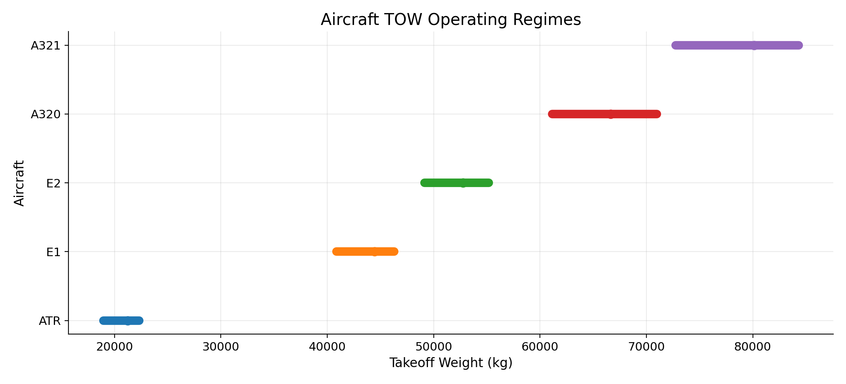
Figure 1 — Take-off-weight regimes by aircraft family. The five P10–P90 bands form a strict mission ladder with limited natural overlap, which is why fair comparisons require a joint sweet-spot rule.
The clear separation between the five bands has an important methodological implication. Comparing aircraft on the full sample would conflate equipment effects with mission effects: an A321 is not less efficient than an ATR — it simply flies a different mission. Any meaningful efficiency comparison must restrict itself to operating conditions where two families demonstrably overlap, which is what the joint sweet-spot construction delivers in the next sub-section.

5.2 Joint sweet spots and fuel-efficiency ladder
Within each equipment family the lower-burn 50 percent of flights defines the sweet-spot zone. The sweet-spot ranges in distance are: ATR best around 221–321 NM; E1 in the short-medium band; E2 most efficient on medium sectors around 442–841 NM; A320 strongest on medium-long sectors around 889–1,188 NM; A321 on long-haul. Within the regional-jet pair, E2 is observed to dominate E1 across a wider window of operating conditions, which is the empirical signal that motivates the substitution test in Section 5.4.

5.3 Behaviour-based clustering
A clustering exercise built on mission profile, sweet-spot mission profile, fuel intensity and the observed fuel slope versus distance recovers three natural groups: ATR alone (turboprop, very different fuel curve and very short stage length); the regional-jet pair E1+E2; and the large-narrowbody pair A320+A321. Inside the regional-jet cluster, E2 visibly dominates E1 across the shared short and medium-haul space — a result that, by construction, is independent of route assignment and therefore robust to network-level confounds.

5.4 Fuel-only substitution screen
Restricting the comparison to routes where two equipment families both operate inside their own joint sweet spots yields three swap directions with statistically informative samples: A320 replacing A321, ATR replacing E1, and E2 replacing E1. On a pure fuel-per-flight basis, all three show savings.
Swap direction | Candidate routes | Worse-aircraft sweet-spot flights | Median fuel saving | Total kg saved
A320 → A321 | 4 | 1,957 | 14.6% | 2,002,389
ATR → E1 | 7 | 459 | 57.5% | 589,842
E2 → E1 | 7 | 641 | 17.7% | 292,487
Table 3 — Fuel-only substitution screen. Values are computed inside the joint sweet spots of the candidate aircraft.
Taken at face value, the table above might suggest that ATR-for-E1 is the most attractive swap. That impression is misleading because it ignores capacity: an ATR carries roughly two thirds of the seats of an E1, so any per-flight saving has to be multiplied by the extra frequencies needed to preserve seat supply. The next sub-section corrects this.

5.5 Equal-seat-supply capacity screen
The capacity screen recomputes the saving under the constraint that the total number of seats offered on each route is held constant. The result reverses the apparent ranking from Section 5.4.
Swap direction | Routes passing screen | Median saving (equal seats) | Total kg saved | Extra flights needed
E2 → E1 | 7 | 26.6% | 480,263 | 0.0%
ATR → E1 | 0 | 33.5% | 327,312 | 68.6%
A320 → A321 | 0 | −4.6% | −602,452 | 23.0%
Table 4 — Substitution results after the equal-seat-supply capacity screen.
Only the E2-for-E1 swap survives. ATR-for-E1 would demand 68.6 percent more frequencies to preserve seat supply, which on the candidate routes is operationally implausible and would erase most of the fuel benefit through extra take-off and landing cycles. A320-for-A321 actually becomes net negative once seat supply is held constant. The conclusion is therefore narrow but unusually robust: among the swap directions the data supports, only one of them is operationally implementable.
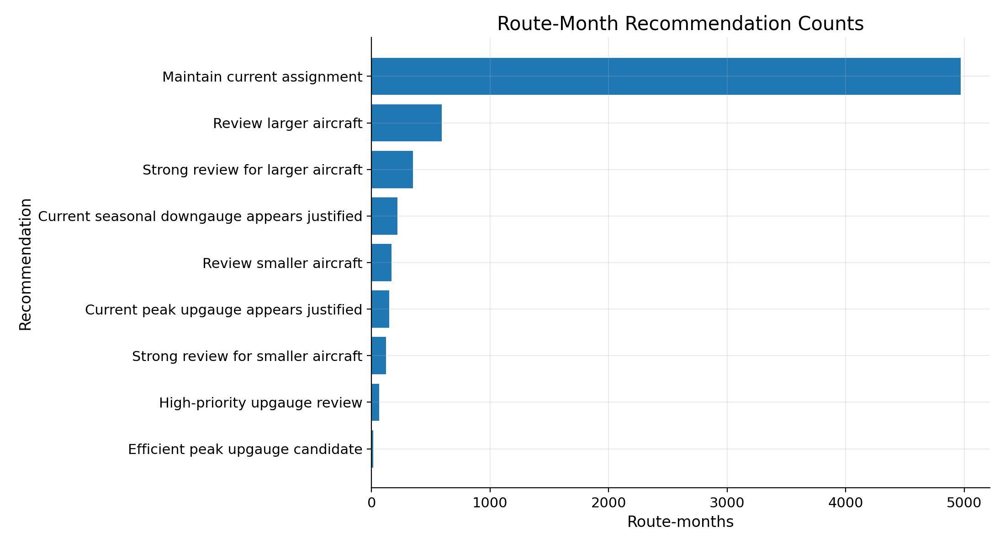
Figure 2 — Distribution of route-month recommendations produced by the seasonal decision engine. The asymmetry confirms that the actionable signal in the dataset is concentrated in a limited number of route-month combinations.

5.6 Seasonal and route-level patterns
To confirm that the E2-for-E1 recommendation is stable across time, the seasonal decision engine recomputes the regime classification on a route-month basis. The output highlights that the highest-volatility corridors — VCP↔SDU, REC↔FEN, FEN↔REC, SDU↔VCP, POA↔VCP — already show migrations of TOW regime across months. On REC↔FEN, for example, the regime moves from ATR in the trough month to E2 in the peak month, with an average TOW shift of more than 30 tonnes between the two seasons. This pattern is consistent with active fleet rotation by Azul and supports the broader argument that the regional-jet swap is the natural lever in the existing network design.
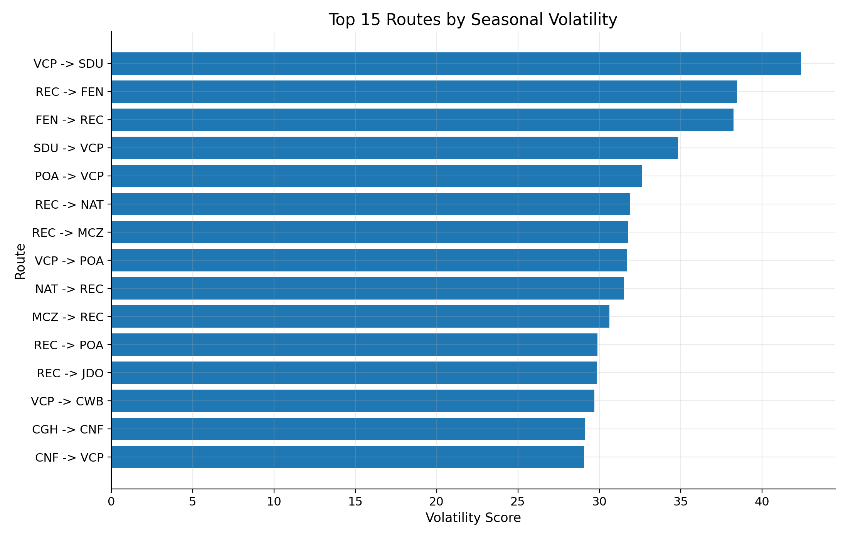
Figure 3 — Top routes by seasonality volatility score. High-volatility routes are those most exposed to demand fluctuation across months and therefore most sensitive to the choice of equipment.

6. Results

6.1 Headline finding
On the seven candidate routes that survive both the joint-sweet-spot filter and the capacity screen, substituting E1 jets with E2 jets reduces fuel consumption by a median of 26.6 percent at equal seat supply, with no additional frequencies required. Applied to the observed worse-aircraft sweet-spot flights, this corresponds to approximately 480,263 kilograms of jet fuel saved over the analysis window of 22 months.

6.2 Financial translation
Converting the fuel saving into financial terms makes the order of magnitude explicit. Using a jet fuel density of 0.8 kg/L and a Brazilian QAV (Querosene de Aviação) reference price of approximately R$5.50 per litre — a midpoint of the range observed across Brazilian airports in 2024–2025 — the 480,263 kg figure translates into roughly 600,329 litres, or about R$3.3 million saved over the 22-month window. Annualised inside the observed sweet-spot sample, this corresponds to approximately R$1.8 million per year.
At face value, R$1.8 million per year is small in proportion to Azul’s total annual fuel expense, which the company reports in the order of single-digit billions of reais. The decisive point, however, is that this number reflects only the 641 flights that the strict joint-sweet-spot filter retained — a deliberately conservative subset of E1 operations. The E1 fleet flies approximately 44,816 movements over the same 22-month period, so the sample used to compute the saving is roughly 1.4 percent of all E1 activity.

6.3 Extrapolation to the broader E1 fleet
The relevant question for Azul is therefore not how much was saved inside the sweet-spot sample, but how much could be saved if the same per-flight economics were applied to the broader subset of E1 operations whose mission profile is compatible with the E2. Inside the observed sample, each substituted flight saves an average of 749 kilograms of jet fuel. Under a conservative scenario in which 20 to 30 percent of E1 movements over a year — between 5,000 and 7,500 flights — fall within an operational profile where the E2 can be substituted with no capacity penalty, the annualised saving scales to approximately 3.7 to 5.6 million kilograms of fuel, or 4.7 to 7.0 million litres.
Translated into BRL at the same QAV reference price, this corresponds to an indicative range of R$26 million to R$39 million per year — between 10 and 20 times the saving computed strictly inside the sweet-spot sample. As a share of Azul’s total fuel bill the number remains modest, on the order of 0.3 to 0.5 percent, but as an isolated operational improvement built on equipment allocation alone — without capital expenditure beyond the E2 induction already under way — it is large enough to justify a deliberate prioritisation policy. The estimate is illustrative and assumes linearity between the sweet-spot sample and the broader E1 population; a tighter figure would require a route-by-route, rotation-by-rotation feasibility check that is outside the scope of this report and naturally constitutes the next refinement of the analysis.

6.4 Why the other swaps are rejected
ATR-for-E1 is rejected because preserving seat supply would require approximately 68.6 percent additional frequencies, which is operationally inconceivable on the candidate routes — it would consume slots at congested airports, add crew and turnaround cost, and dilute the per-flight saving through the extra take-off and climb phases that are themselves fuel-intensive. A320-for-A321 is rejected outright because once seat supply is held constant the swap becomes net fuel-negative.

6.5 Practical interpretation
The recommendation is restricted to the regional-jet pair, which is the most coherent operational space in Azul’s fleet. Inside the candidate corridors, every E1 rotation whose mission profile is compatible with the E2 should become a priority allocation target for the next E2 unit entering service. Azul’s ongoing E2 induction programme provides the structural reason why this recommendation is implementable without new capital decisions: the operator is already on a trajectory of replacing E1 capacity with E2 capacity, and the analysis simply identifies the corridors where that replacement yields the largest measurable fuel benefit.
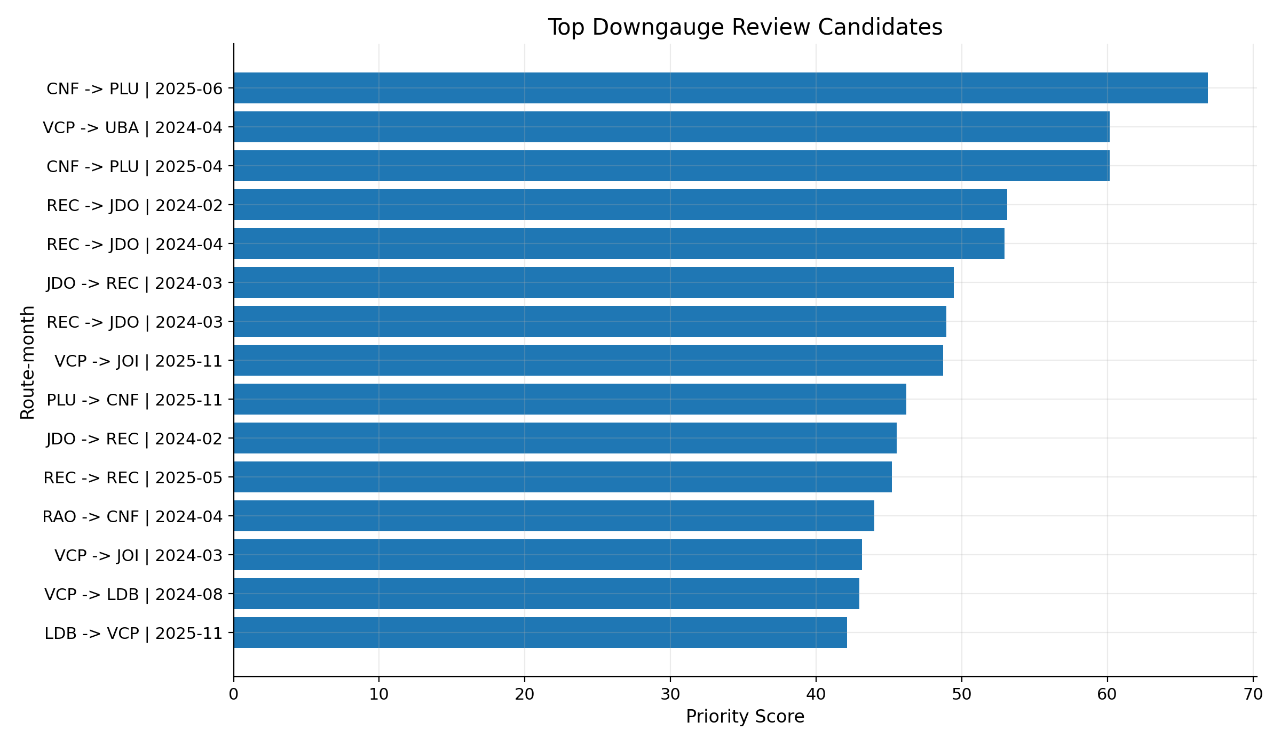
Figure 4 — Top candidate routes for downgauging, ranked by priority score. The score combines fuel saving, sample density, and seat-supply feasibility.

7. Discussion

7.1 Robustness of the conclusion
The E2-for-E1 result is robust in three independent senses. First, it is built inside operating conditions where both families actually appear in the data, which removes extrapolation risk. Second, it survives a capacity correction that is deliberately conservative — equal seat supply, not equal revenue or equal load factor. Third, it agrees qualitatively with the behaviour-based clustering in Section 5.3, which separated ATR from the regional-jet pair and from the large-narrowbody pair on operational grounds alone.

7.2 Alternative levers worth testing
The route-swap logic is only one of several possible levers. The dataset supports four complementary directions of investigation that the team flags as natural next steps. The first is gauge-by-departure-wave, which would allow Azul to use a larger aircraft only during peak banks and a regional jet off-peak on the same city pair. The second is the optimisation of fuel per seat-NM rather than fuel per flight, which would internalise the capacity trade-off automatically. The third is dynamic up-gauging and down-gauging across weekdays and holiday periods, which the seasonal engine already produces month-level recommendations for. The fourth is the investigation of the tail routes with poor fuel-per-NM performance inside the same aircraft family, which often reveal operational inefficiencies — payload mix, weather exposure, taxi-out times — that are independent of the equipment choice.

7.3 Strategic implications for Azul
Three points deserve to be highlighted at decision-maker level. First, the analytical result aligns with the direction Azul has already taken with its E2 fleet plan, which raises the confidence that the conclusion is not an artefact of the methodology. Second, the magnitude of the saving — measured here in kilograms of fuel, but immediately convertible into BRL and into CO₂-equivalent emissions — is sufficient to anchor an internal allocation guideline, not merely a one-off study. Third, the rejection of the A320-for-A321 swap is a useful counter-result: it shows that the larger-narrowbody space is already close to its operational optimum and that further fuel gains in that segment will require non-equipment levers (operational procedures, weight reduction, fuel hedging, etc.).

8. Recommendation

8.1 Framing
Before stating the recommendation it is necessary to clarify what this report is not recommending. Azul is already a launch operator of the Embraer E195-E2 and is executing a publicly disclosed programme of progressive E1 retirement and E2 induction. A recommendation framed as “replace E1 with E2” would therefore restate an existing corporate decision rather than contribute analytical value. The contribution of this work is more precise: it is a prioritisation rule that tells Azul where, on its existing network, the next E2 unit entering service generates the largest fuel benefit at no operational penalty.

8.2 Primary recommendation
As E2 capacity enters the fleet through the ongoing induction programme, Azul should prioritise the allocation of incoming E2 frames to the seven regional and medium-haul corridors identified by the joint sweet-spot and capacity screens. Each E2 unit assigned first to these corridors, rather than to other route groups inside the network, captures the 26.6 percent equal-seat-supply fuel reduction documented in Section 5.5 and avoids diluting the benefit in operating conditions where the E2 advantage over the E1 is smaller.

8.3 Secondary recommendations
- Use the route-month outputs of the seasonal decision engine to guide dynamic up- and down-gauging on high-volatility corridors (VCP↔SDU, REC↔FEN, POA↔VCP), rather than locking equipment to a route year-round.
- Reject — explicitly — the ATR-for-E1 and A320-for-A321 substitutions in their current form; either is at best a marginal lever and at worst fuel-negative once capacity is held constant.
- Re-run the pipeline at least quarterly so that changes in network design (new city pairs, retirements, schedule density) are reflected in the recommended equipment allocation.
- Integrate passenger demand, load factor and revenue data when they become available; this would upgrade the capacity screen from “equal seats” to “equal revenue” and is expected to refine, not invalidate, the present conclusion.

8.4 Implementation pathway
The recommendation does not require capital investment beyond the E2 fleet that Azul is already inducting. The implementation pathway is therefore one of allocation discipline rather than acquisition: identify the E1 rotations on the seven candidate corridors, locate incoming E2 frames whose turnaround windows are compatible with those rotations, and reassign at the next scheduling cycle. A pilot phase on two or three of the highest-priority corridors — measured by total flights inside the sweet spot — would generate fast feedback at low operational risk before any network-wide rollout. The accompanying scope of the next analytical cycle is to convert the indicative annualised range presented in Section 6.3 into a route-by-route, rotation-by-rotation feasibility plan.

9. Implementation Barriers
The analytical case for prioritising E2 allocation on the seven candidate corridors is strong, but the operational path from recommendation to execution is constrained by a series of barriers that this report acknowledges explicitly. The barriers are not arguments against the recommendation; they are the boundary conditions that determine its pace and sequencing.

9.1 Fleet rollover and contractual constraints
The E1 frames currently in Azul’s fleet are held under a combination of ownership and operating-lease structures with defined contractual horizons. Substituting an E1 rotation with an E2 rotation only delivers the fuel saving from the moment the E1 is retired or redeployed; until then, the E1 continues to generate lease or amortisation charges regardless of whether it flies. Any acceleration of the substitution beyond the natural rollover schedule therefore requires either early-termination negotiations with lessors or the absorption of stranded-asset cost. This is the single largest determinant of the pace at which the recommendation can be executed.

9.2 Embraer delivery lead time
The recommendation depends on E2 frames entering service. The current Embraer order book and production rate impose a lead time typically measured in 12 to 24 months between a firm-order amendment and the corresponding delivery slot. Even if Azul wishes to accelerate the migration on the seven corridors, the upper bound on the speed of execution is set by the manufacturer, not by the operator.

9.3 Crew, type rating and training
The E1 and E2 share a common pilot type rating in most regulatory jurisdictions, which is the principal commonality argument advanced by Embraer for the E2 family. The practical implication is that the substitution does not require a full retraining cycle, but differences training, simulator currency and recent-experience requirements for each individual crew member still apply. Crew availability for the E2, especially for captains with sufficient hours on type, is therefore a soft constraint that may bind in the early stages of an accelerated allocation policy.

9.4 Airport slots, gates and ground infrastructure
The candidate corridors include city pairs that touch slot-constrained or gate-constrained airports — CGH, SDU and similar facilities. Reassigning an E2 to a rotation that previously operated as an E1 does not in itself consume additional slots, since the frequency count is preserved. However, the E2 is a larger physical airframe, with different gate compatibility, jet-bridge geometry and ground-handling requirements at some stations. The substitution must therefore be verified station-by-station rather than route-by-route.

9.5 Multi-leg rotation logic
Commercial aircraft do not operate isolated routes; they operate rotations that chain four to ten legs in a single duty period. Substituting equipment on a single segment of a rotation forces a recalculation of the entire rotation: crew duty time, maintenance check intervals, fuel uplift planning, ground-time tolerances and connection feeds at hubs. The seven corridors identified in Section 5 must therefore be evaluated within the context of the rotations that already operate them, and not as standalone segments. This is the operational reason why the report recommends a staged pilot rather than a network-wide swap.

9.6 Differential operating economics
The E2 has higher capital cost and higher direct operating cost per hour than the E1, even though it has lower fuel burn per seat-mile. The fuel saving captured in the analysis is therefore a gross figure, not a net contribution margin. A complete net assessment would deduct the incremental ownership cost of the E2 over the E1 from the fuel saving, and would require Azul-internal data on lease rates, maintenance reserves and crew costs that the dataset used for this study does not contain. The recommendation is robust on a fuel-only basis; on a full-cost basis it is expected to remain positive on the seven candidate corridors but the margin will be narrower than the headline 26.6 percent suggests.

10. Limitations
Three sources of uncertainty should be acknowledged explicitly. First, the dataset contains no passenger demand, load factor, or revenue information; the capacity screen consequently uses seat capacity as a proxy, which is conservative but not equivalent to a true demand model. Second, the joint sweet-spot rule is by construction a sample-based definition; routes with very few observations inside the sweet spot of both families are excluded, which means the analysis is silent on city pairs where the operational overlap is thin. Third, the airport infrastructure constraints — runway length, gate availability, slot allocation, payload restrictions — were not modelled at airport level and are treated qualitatively in Sections 7 and 9. A formal infrastructure screen would refine, but is not expected to overturn, the central conclusion that E2-for-E1 is the only swap that survives the dual filter applied here.

11. Conclusion
The analysis converts the Azul operational dataset into a single, narrow and defensible recommendation: prioritise the allocation of incoming E2 frames to the seven regional and medium-haul corridors where the two regional-jet families’ operating envelopes overlap. The recommendation delivers a median fuel reduction of 26.6 percent on the substituted segments at equal seat supply, requires no additional frequencies, and is operationally compatible with Azul’s existing E2 induction trajectory. The two alternative swap directions tested are rejected on capacity grounds. The methodology used to reach this conclusion — staged filtering, sweet-spot conjunction, capacity correction — is itself a contribution: it is reproducible, conservative, and traceable to the public repository that documents the full pipeline. The remaining work, naturally, is to integrate true demand data, infrastructure constraints, and a financial layer expressing the saving in BRL and in tonnes of CO₂-equivalent.

12. References
Azul Linhas Aéreas Brasileiras (2025). Operational flight-level dataset, 1 January 2024 to 15 November 2025. Internal data extract provided to Team 5.
Embraer S.A. (2024). E-Jets E2 Family: Technical Description and Performance Data.
International Civil Aviation Organization (ICAO) (2022). Fuel-Efficiency Initiatives in Commercial Aviation.
Team 5 (2026). Azul Fleet Reassignment Analytical Pipeline. GitHub repository — github.com/EduardoInsper/Azul. Notebooks, decision engine and supporting CSV outputs.
Belobaba, P., Odoni, A., & Barnhart, C. (Eds.) (2015). The Global Airline Industry, 2nd Edition. John Wiley & Sons.

